**Task 3:  ACL**

Let us apply ACL (Access Control List) on the topology. First, let us assign IP addresses and change the state of the interfaces.   
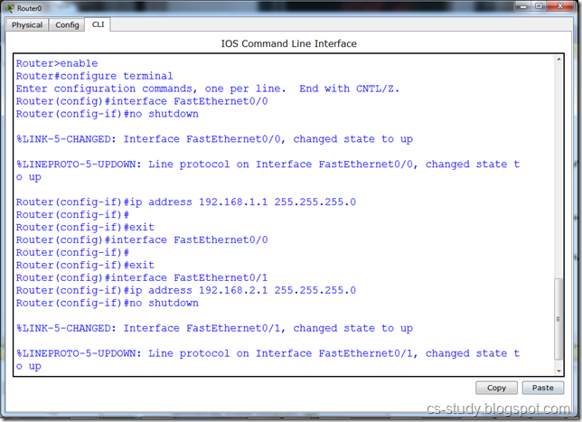  
Here, the status is change as shown in the following diagram.   
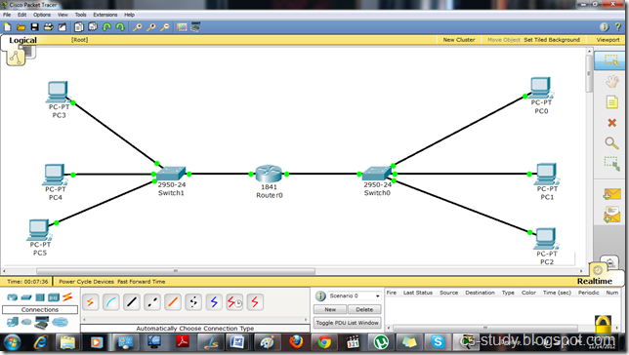  
Then, we will have to assign IP addresses to the PCs.   
 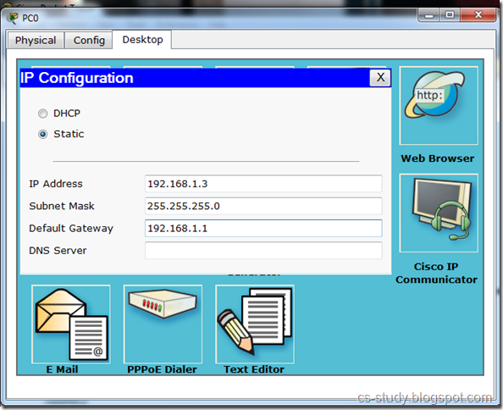   
And the PC attach to the other interface. Please note the difference between default gateways. We assign fast Ethernet interface address to default gateway.   
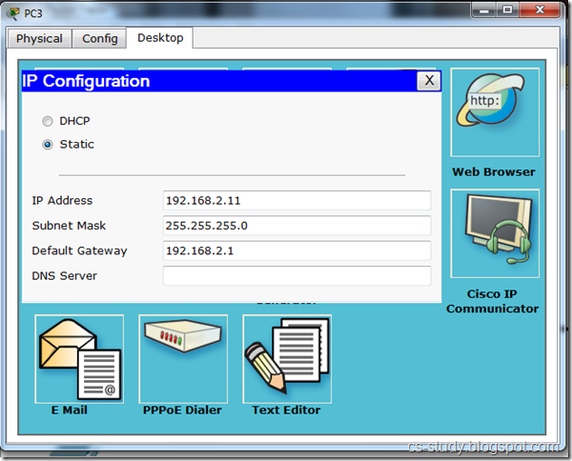   
Thus, after applying IP addresses. We see that Packet transfer is successful.   
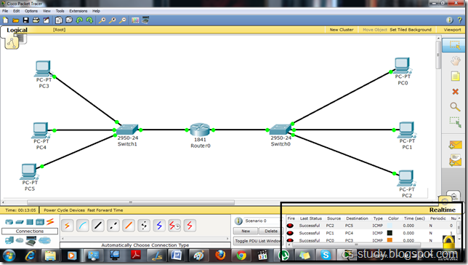  
Let us apply ACL and permit and deny Hosts IP’s as we want. We are going to deny and permit certain hosts as follows.   
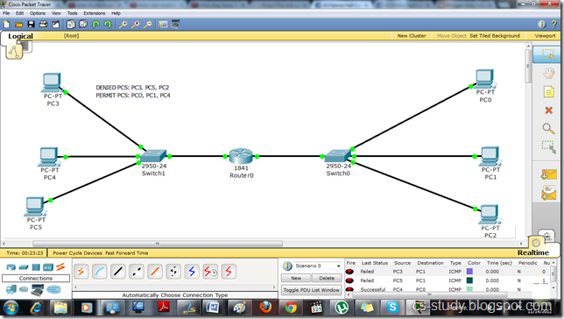  
Let us apply ACL and permit and deny Hosts IP’s as we want.   
 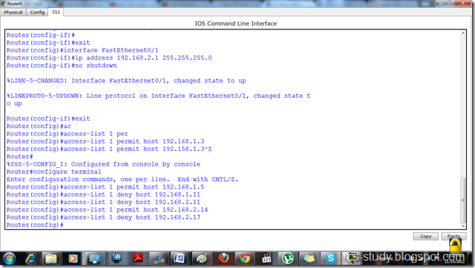  
Then, we will have to tell the interface that which ACL to follow. ACL is uniquely identified with the number, in this case 1.   
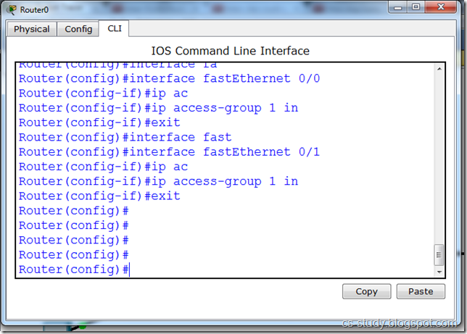  
Now, you see that the denied will not be able to send the data while those who we permit can send packet.   
 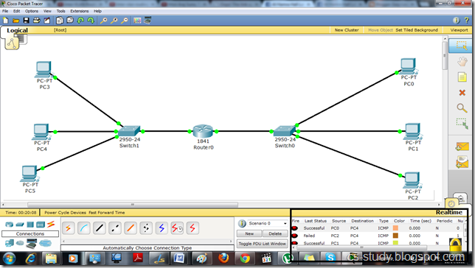  
Similarly, in the bottom right corner you can see status.   
